1. 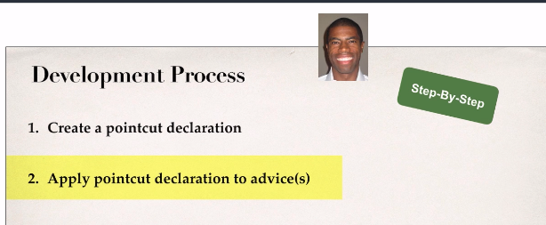
2. Same Code as in the previous lecture.